Plate Tectonics Study Guide (Chapter 17)
- Who is Wegener? Explain what he studied.
- What evidence did Wegener provide to support continental drift?

- How did glacial deposits support Wegener’s theories?
- Why was Wegener’s hypothesis rejected at first?
- What evidence about topographic, sedimentary, age and magnetic data from the seafloor help explain seafloor spreading.
- Why was seafloor spreading the missing link to Wegener’s model?
- Explain the theory of plate tectonics.
- Label the types of boundaries pictured below.
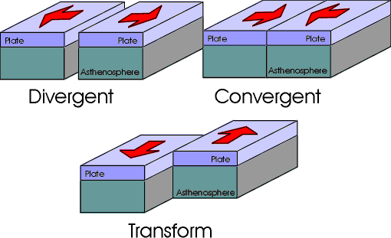

- What is a rift valley?
- What is subduction?
- What is happening to crust at divergent, convergent and transform boundaries?
- Explain what happens at an oceanic-continental convergence.
- What geologic features are associated with each type of convergent boundary?
- Explain mantle convection.
- How are convergent and divergent boundaries related to the flow direction of mantle convection?

- How is mantle convection related to the movements of tectonic plates (think push and pull)?

