Name: ________________
7th grade Science Semester Exam Study Guide
Forms of energy, energy transfer, sound, physical and chemical properties and reactions/changes, elements, periodic table
Energy
Vocabulary to know:
Energy
Kinetic Energy
Potential Energy
Law of conservation of energy
Energy efficiency
Chemical Energy
Mechanical Energy
Nuclear Energy
Sound Energy
Electromagnetic Energy
Heat Energy
Electrical Energy
Comprehension Questions
- Is chemical energy considered potential or kinetic? Why?

- Why does a book sitting on a table have potential energy?

- If an object has energy, then that object has the ability to cause ____________.

- What law states that the total amount of energy in the universe never changes (it is never created or destroyed)

- Energy occurs in many _______________.

- What two main types of energy relate to motion?

- State an example for an energy transfer that involves electrical energy being changed into thermal energy.

- Give an example of chemical energy being converted to thermal energy.

- Give an example of electrical energy being converted to mechanical energy.

Complete the chart
Example Forms of Energy PRODUCED by each example
Windmill
Microwave
Firecracker
Bicycle
Battery
A band playing
Child running
Flashlight
Fire
Car moving
Sun

Use the figure below to answer questions 10-12.

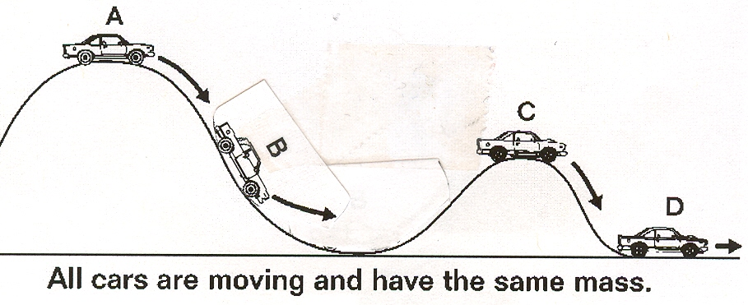

- What car has the GREATEST potential energy?

- What car has the LEAST potential energy?

- Which car has the GREATEST kinetic energy?

Sound
Vocabulary
Amplitude
Mechanical waves
Compression/longitudinal waves
Infrasonic
Intensity
Pitch
Ultrasonic
Oscilloscope

Concept Questions
- What are the two factors that affect the speed of sound?

- The speed of sound is affected by the material of the medium. Order the following from slowest to fastest: air, steel, water.

- Is the speed of sound affected by the density of the material it travels through? How?

- The more energy a wave has the greater its ____________________ will be.

- Draw a graph of a wave representing a sound that is low-pitched and soft.

- Draw a graph of a wave representing a sound that is low-pitched and loud.

- Draw a graph of a wave representing a sound that is high-pitched and soft.

- What is the speed of sound in air? Water? Solid?

- What unit is used to represent frequency?

- What is the organ in the ear that contains many tiny hairs?

Mixtures, elements, compounds
- Ultimately, all matter can be classified as mixtures, elements and compounds.
- ___________ – two or more substances that are not chemically combined with each other and can be separated by physical means. The substances in a mixture retain their individual properties.
- Solutions –
- ____________ – simplest form of pure substance. They cannot be broken into anything else by physical or chemical means.
- Compounds –
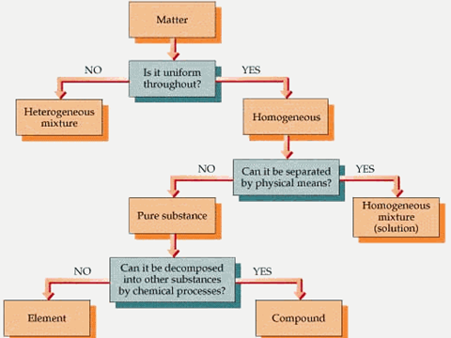
Is it uniform throughout?
- If the answer is no, the matter is a _____________________ mixture.
  - Considered the “________mixed.”
  - Does not appear to be the same throughout.
  - Particles are large enough to be seen and to be separated from the mixture.
Examples of heterogeneous mixtures: Sand and pebbles, Oil and water, Powdered iron and powdered sulfur
Is it uniform throughout?
- If the answer is yes, the matter is homogeneous (looks the same throughout).
  - That leads us to another question.
Can it be separated by physical means?
- If the answer is yes, the matter is a homogeneous mixture or solution.
Homogeneous Mixtures
- A mixture that appears to be the ________ throughout.
- It is “well mixed.”
- The particles that make up the mixture are very small and not easily recognizable.
- Milk, toothpaste, and mayonnaise are homogeneous mixtures. They are also colloids.
- In a _________ the particles are mixed together but not dissolved.
- The particles are relatively large and are kept permanently suspended.
Solutions
- A solution is a type of homogeneous mixture formed when one substance _____________ in another.
- It is the best ________ of all mixtures.
- A solution always has a substance that is dissolved and a substance that does the dissolving.
- The substance that is dissolved is the ___________ and the substance that does the dissolving is the _________.
The universal solvent: Water
Water as a solvent:
- Many liquid solutions contain water as the solvent.
- Ocean water is basically a water solution that contains many salts.
- Body fluids are also water solutions.
- Air is a solution of oxygen and other gases dissolved in nitrogen
Can it be separated by physical means?
- If the answer is no, the matter is a __________________.
  - An element
  - Or a compound
- ____________ are the simplest pure substance.
  - An element ________ be changed into a simpler substance by heating or any chemical process.
- The smallest particle of an element that has the properties of that element is called an _________.
  - An atom is the_________________________________________________________.
- There are more than one hundred known elements in the universe listed on the periodic table of elements.
  - These elements combine in such a way to create millions of compounds.
  - All elements are made of atoms.
  - Atoms of the same element are alike.
  - Atoms of different elements are different.
- Compounds are also pure substances.
- But _________________ are made from more than one _____________.
- Water is a compound.
- Water can be broken down into simpler substances – ____________________________________.
Physical and Chemical Properties
All substances have properties that we can use to identify them. For example we can identify a person by their face, their voice, height, finger prints, DNA etc. The more properties that we can identify, the better we know the person. In a similar way matter has properties - and there are many of them. There are two basic types of properties that we can associate with matter. These properties are called Physical properties and Chemical properties:
Physical properties: | Properties that do not change the chemical nature of matter
Chemical properties: | Properties that do change the chemical nature of matter

Examples of physical properties are: color, smell, freezing point, boiling point, melting point, infra-red spectrum, attraction (paramagnetic) or repulsion (diamagnetic) to magnets, opacity, viscosity and density. There are many more examples. Note that measuring each of these properties will not alter the basic nature of the substance.
Examples of chemical properties are: heat of combustion, reactivity with water, pH, and electromotive force.
The more properties we can identify for a substance, the better we know the nature of that substance. These properties can then help us model the substance and thus understand how this substance will behave under various conditions.
Physical and Chemical Properties
Vocabulary

Physical Change:

- Physical Properties:

  - Density: the mass per unit volume of a substance. You can think of it as the amount of stuff something has in the space that it takes up.
  - Thermal conductivity:
  - Electrical conductivity:
  - Ductility:
  - Brittleness:
  - Elasticity:
  - State:

  - Malleability:
  - Solubility:
This can be a confusing property. The way to think about it is this: if I dissolve sugar into water and then leave that sugar water in the sun until all the water evaporates, then I get sugar with the same properties at the end of the process.

Chemical Change:
- Chemical Property:
  - Reactivity:
Baking soda reacts with vinegar to make carbon dioxide but we can only see baking soda’s reactivity if we combine it with vinegar. Iron reacts with oxygen to form iron oxide (rust).
  - Flammability:
I can only observe a match’s flammability by burning it.
  - Rusting:

Development of Atomic Theory: Part 2 (Rutherford to Modern Theory)

In 1909 a former student of Thomson’s, Ernest Rutherford decided to test the idea that electrons are evenly distributed throughout the atom. Draw a diagram that shows Rutherford’s Gold Foil Experiment.
What did Rutherford discover about the movement of the particles that he shot at the gold foil? | - Most of the particles ____________________  _______________________________________  - But surprisingly a few particles ____________  ___________________________ and some even ________________________________
Due to the results of his experiment Rutherford revised the atomic theory in 1911. Complete the statements that describe Rutherford’s revised atomic theory. | Result: Most of the positively charged particles went straight through the gold foil.  Atomic Theory: Most of the matter of the atom is found in a _________________part of the atom. This is called the ___________ of the atom. It is very tiny and extremely __________.  Result: Some of the positively charged particles  were deflected or even bounced back.  Atomic Theory: Like charges repel so the nucleus must have a _____________________. If electrons have a negative charge they could not be in a positively charged nucleus. Electrons must ______________________________________.  Result: The diameter of the nucleus is 100,000 times smaller than the diameter of the entire gold atom.  Atomic Theory: Atoms are mostly ______________ with a tiny, massive _________________________.
Explain why the head of a pin compared to the diameter of a stadium is like an atom?
In 1913, Niels Bohr studied the way that atoms react to light.
- What did he learn about electron movement?
- Can they change paths?
The Modern Theory of the atom states that electrons do not travel in specific paths or orbits.
- Describe the region where electrons travel.
- Can we predict where an electron may be found?
Electron clouds exist at a certain Energy Level. Therefore the energy that an electron has is based on what?
Explain how the bookshelves can help you understand the movement of electrons in an atom.
Atoms are very small.
- How many atoms could fit inside a penny?
We still are not able to see an actual picture of an atom but what can a scanning tunneling electron microscope show us?

Elements, periodic table notes that you get this week will also need to be studied.

